5.17

a. continuous because the amount dispense can be any rational number between 6.5 and 7.5

b. f(x) = 1 / (7.5 - 6.5) = 1

c. μ = 6.5 + 7.5 / 2 = 7 σ = 7.5 – 6.5 / √12 = 0.2887

μ - 2σ = 7 – 2 (0.2887) = 6.4226

μ + 2σ = 7 + 2 (0.2887) = 7.5774

d. P(x >= 7 ) = P(z > 0 ) =0.50

e. P(x<6) = P(z<-3.46) = 0

f. P(6.5 < x < 7.25) = P(-1.73 < z < 0.87 ) = .4582 + .3078 = 0.766

g. P(x>7.25) = P(z>.86) = (0.25)6 = .0002

1 – (7.25 – 6.5 / 7.5 – 6.5 ) = 0.25

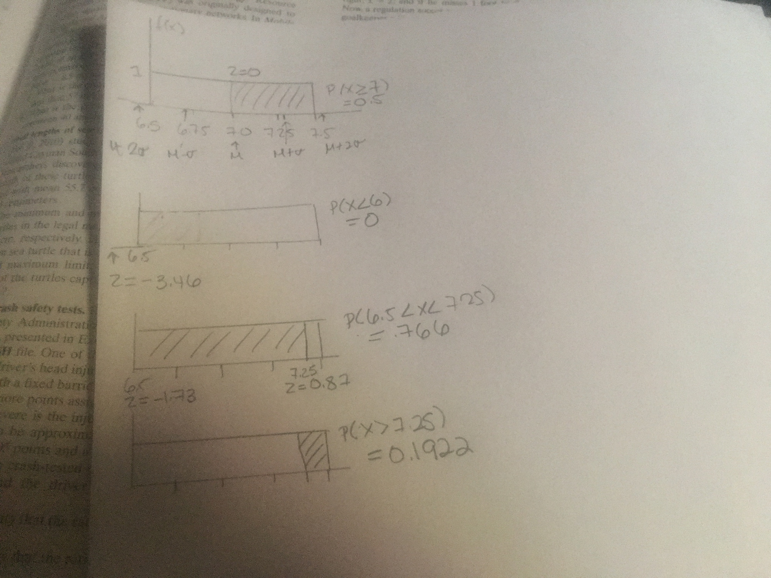

5.38

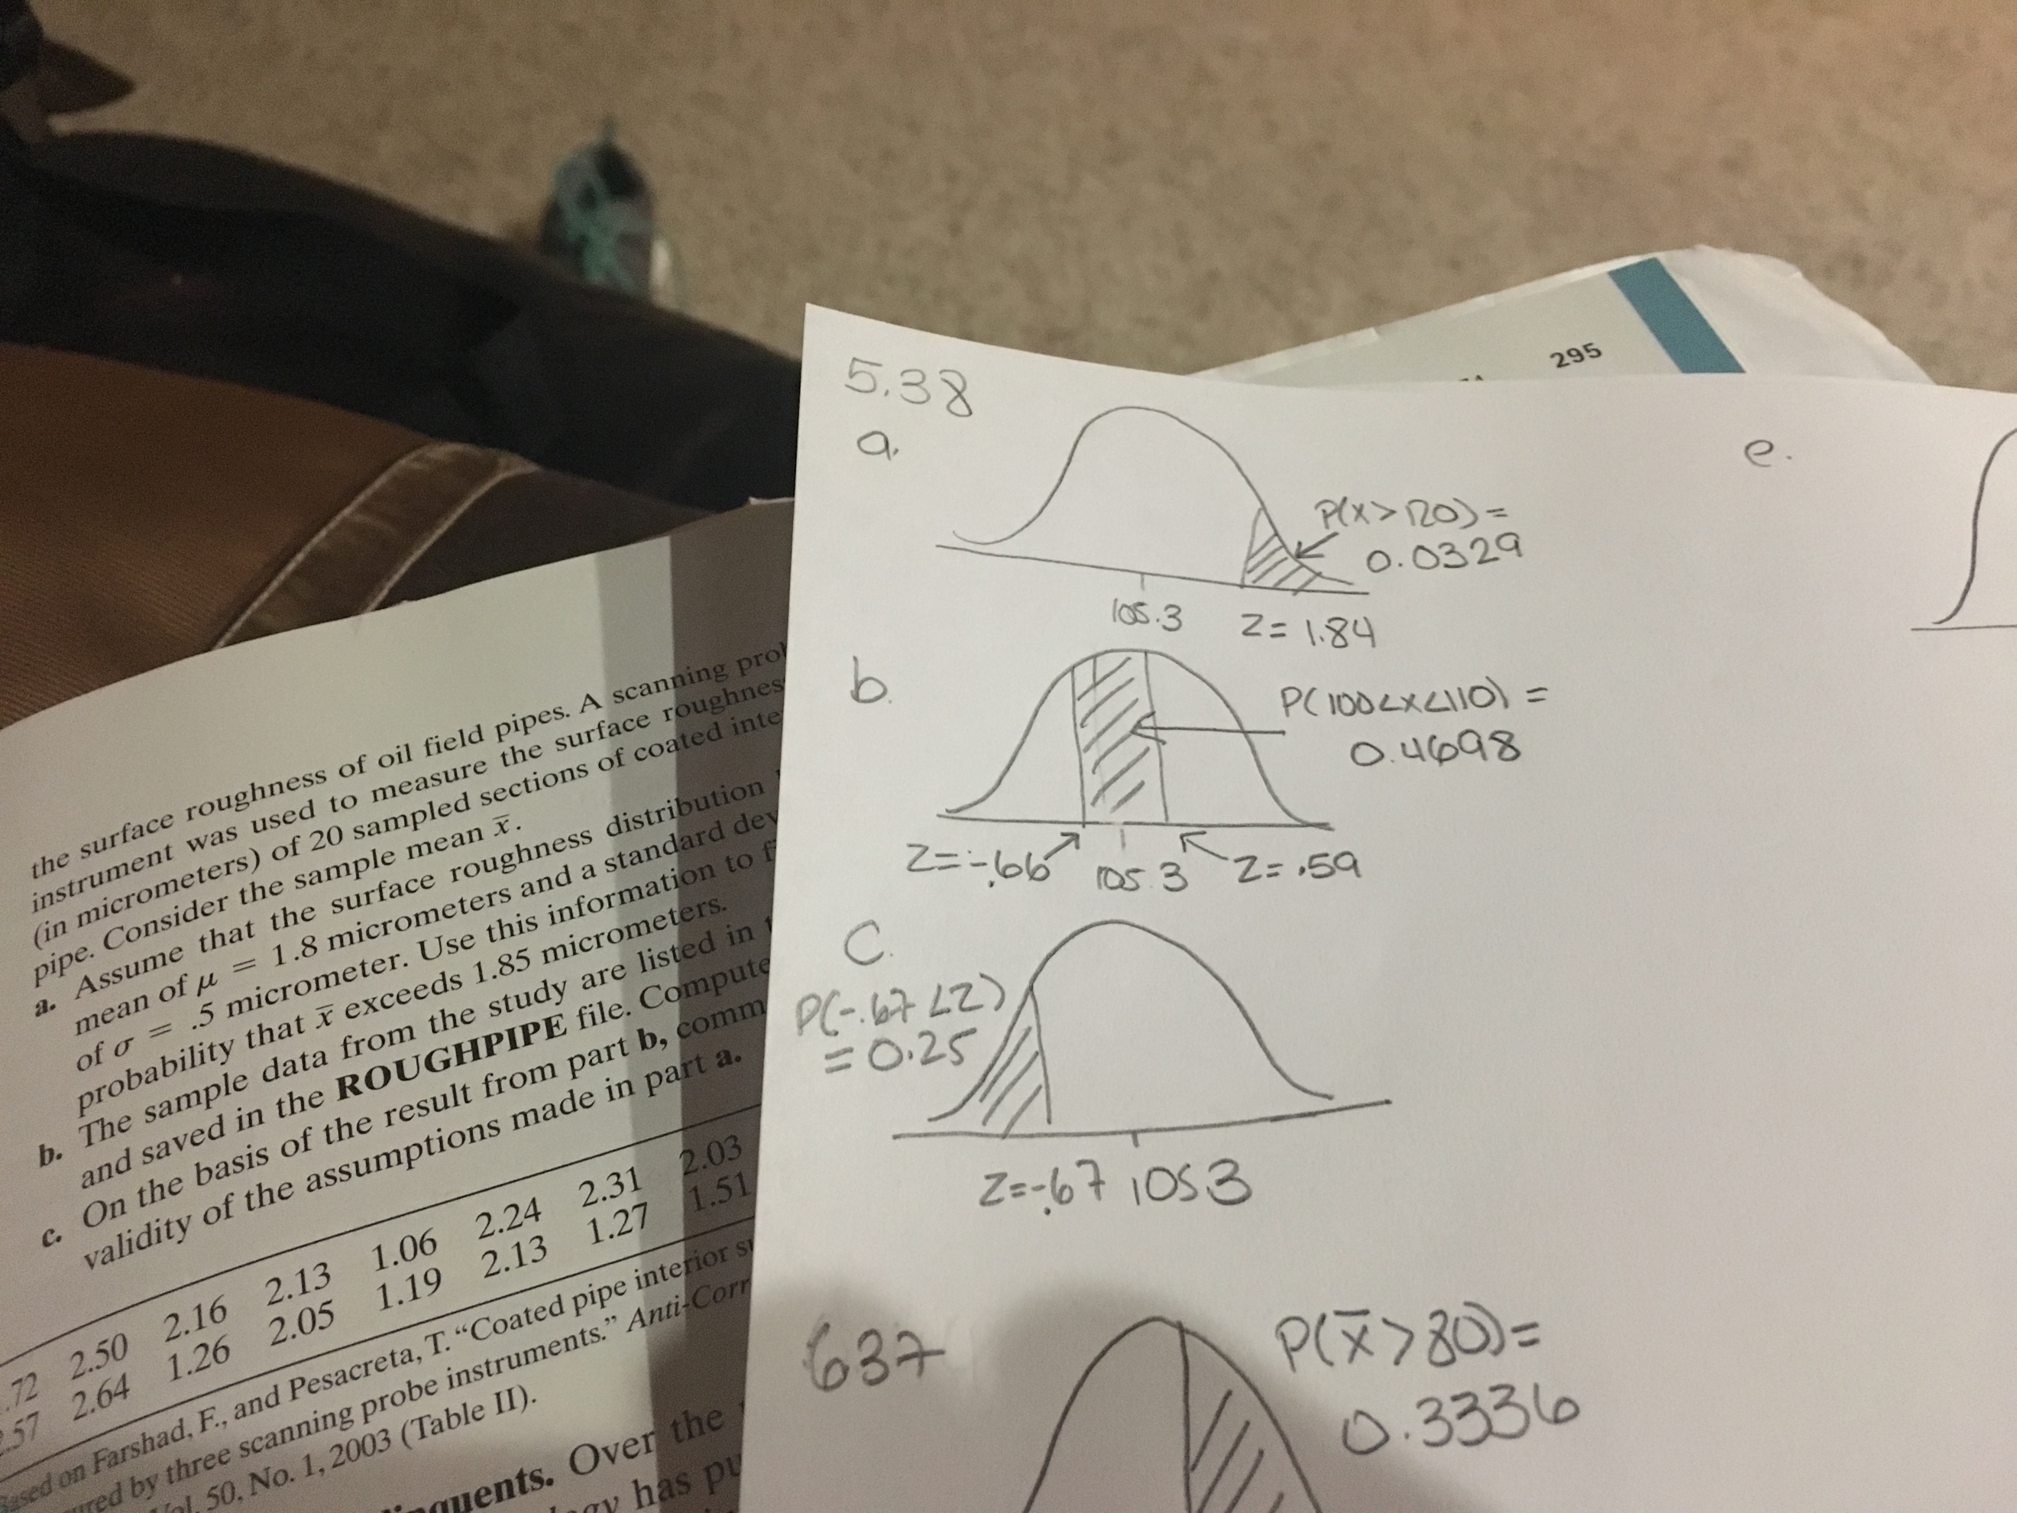

mean = 105.3 std dev = 8.0

1. P(x > 120)

P(z > 1.84) = 1 - 0.5 + .4671 = 0.0329

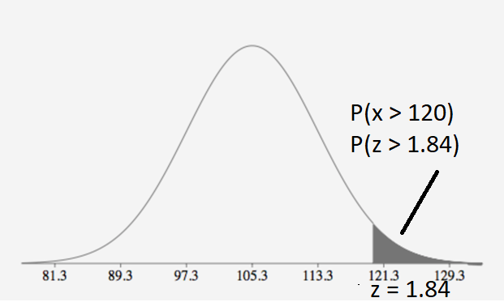

1. P(100 < x <110)

P(-0.66 < z < .59) = .2244 + .2454 = .4678

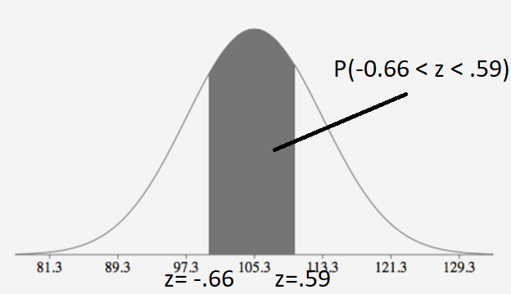

1. P(x < a) = .25

P(-.67 < a ) = .25

-0.67 = a – 105.3 / 8

a = 99.94

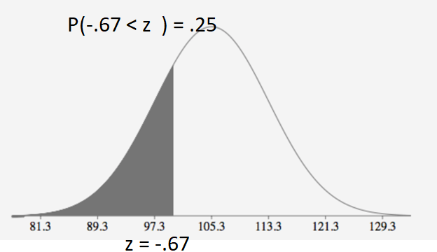

5.44

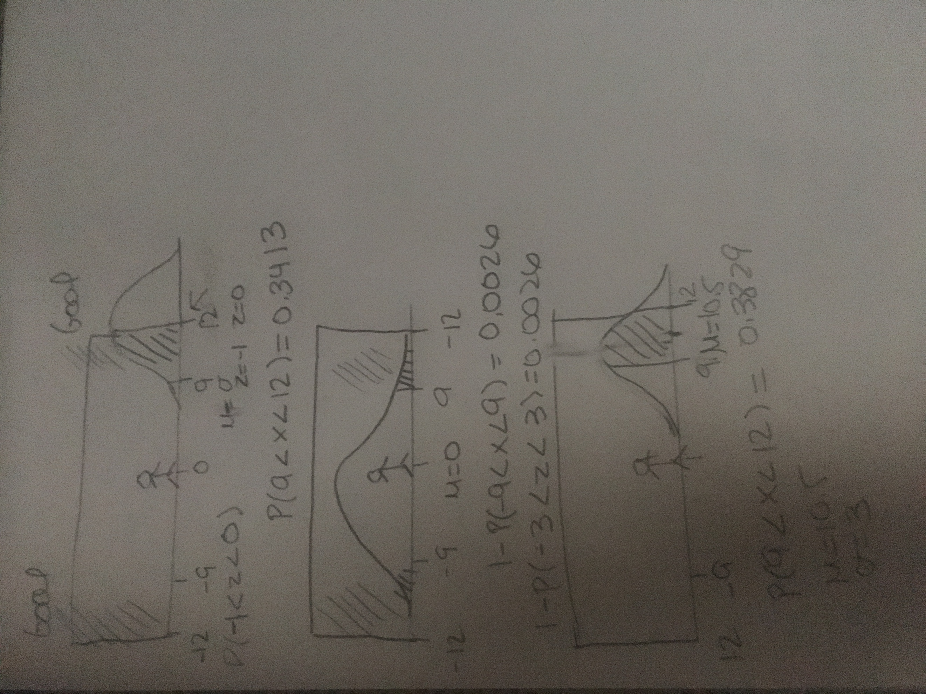

mean = 0 std dev = 3

1. μ = 12 σ = 3 P(9 < x < 12) = P(-1 < z < 0) = 0.3413

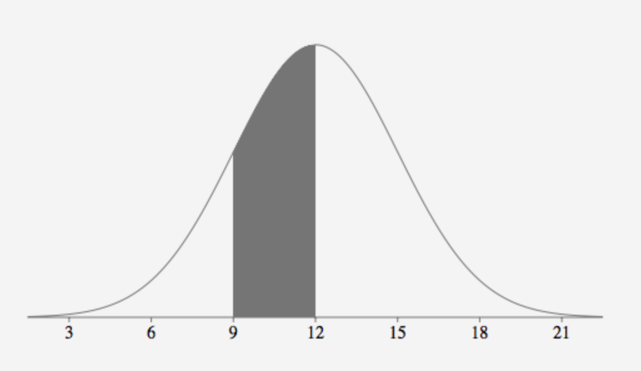

1. μ = 0 σ = 3 1 - P(-9 < x < 9) = 1 - P(-1 < z < -1) = 0.0026

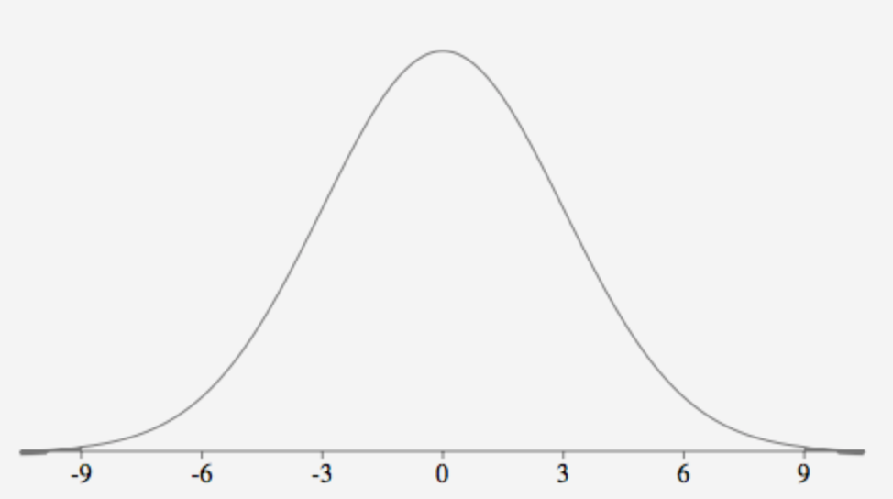

1. μ = 0 σ = 3 1 - P(-9 < x < 9) = 1 - P(-1 < z < -1) = 0.3829

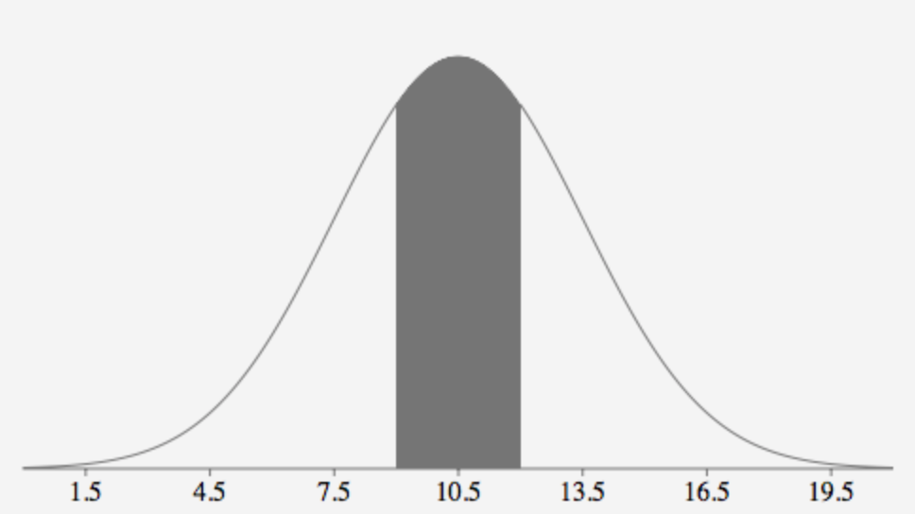

6.37

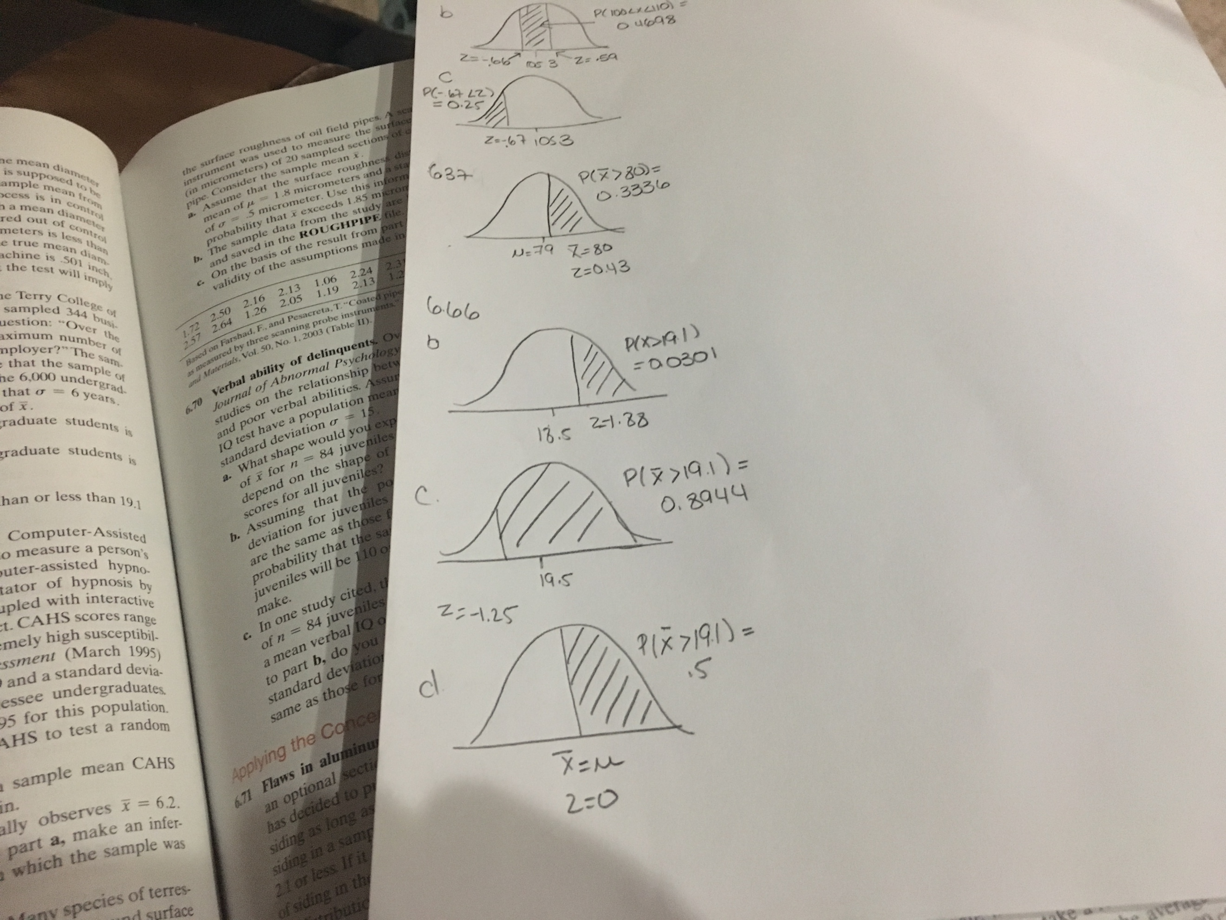

mean = 79 std dev= 23 n =100

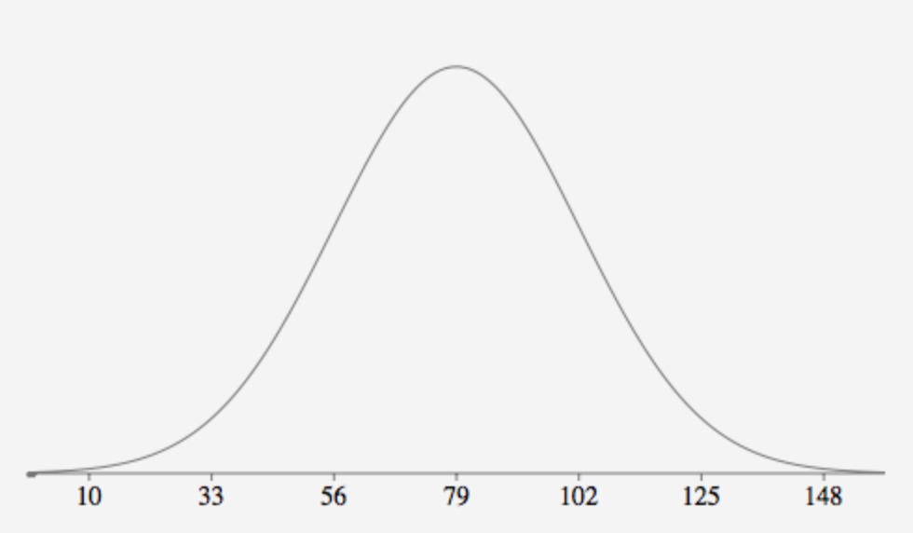

a.79

b. 23/sqrt(100) = 2.3

c. Approximately normal with a mean of about 79 and standard deviation of about 2.3

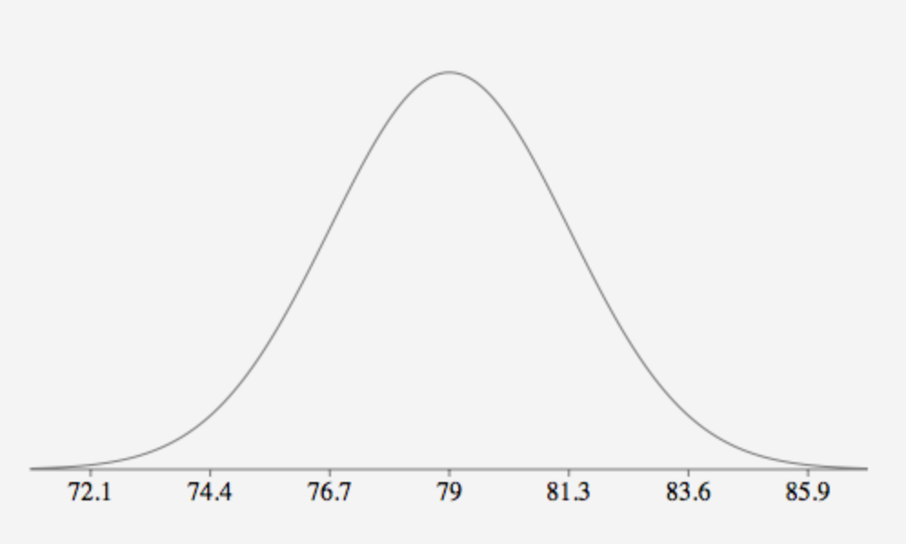

1. 80 – 79 / 2.3 = 0.43

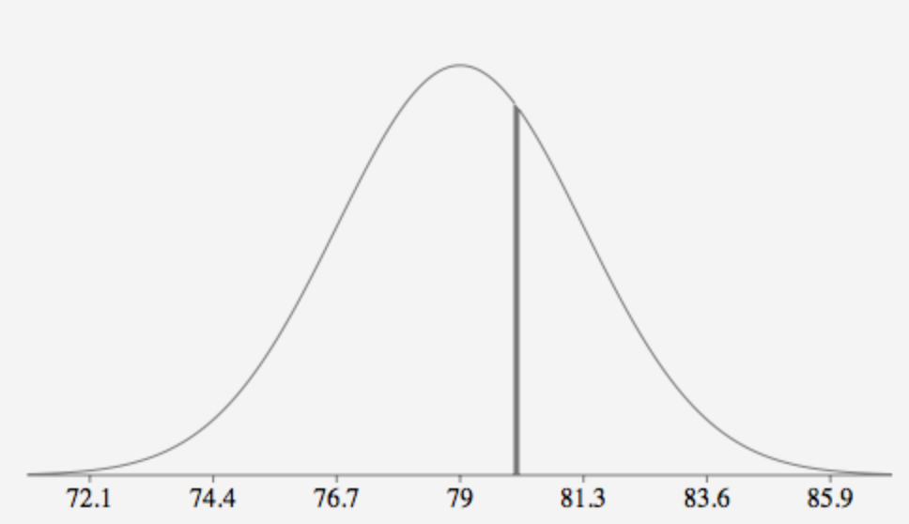

1. P(x > 80) = P(z > 0.43) = 0.5 – 0.1664 = 0.3336



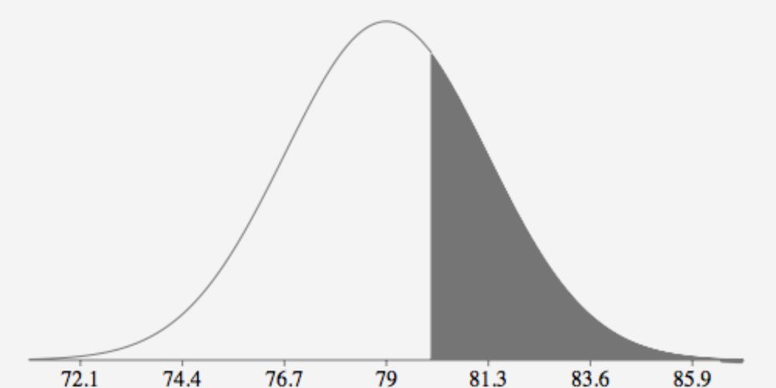

6.66

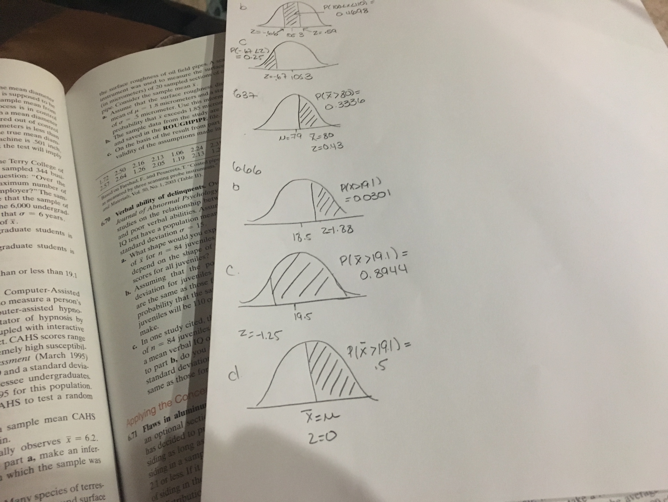

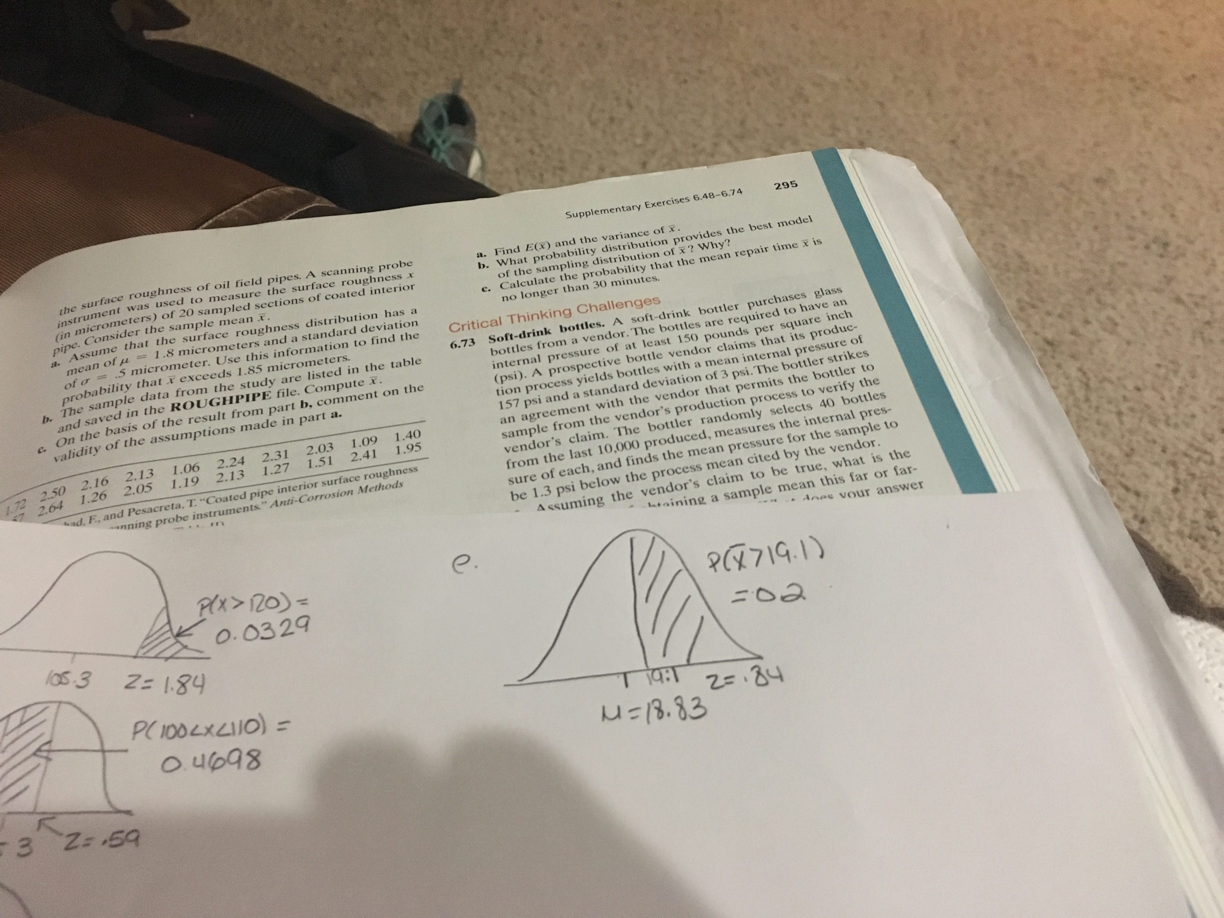

n = 344 x= 19.1 std dev = 6

1. Approximately normal with a mean of about 19.1 and standard deviation of 0.32
2. P(X > 19.1) = 19.1 – 18.5 / 0.32

P(z > 1.88) = .5 - .4699 = 0.0301

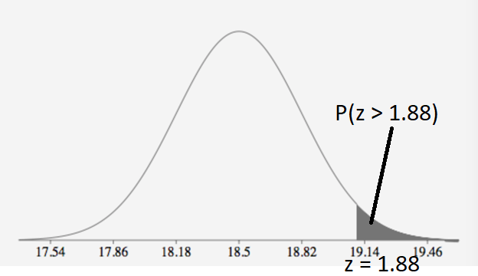

1. P(X > 19.1) = 19.1 – 19.5 / 0.32

P(z > - 1.25) = .5 + .3944 = 0.8944

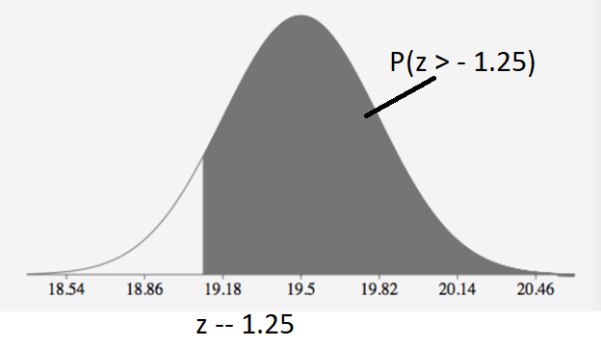

1. P(X > 19.1) = .5 u = 19.1

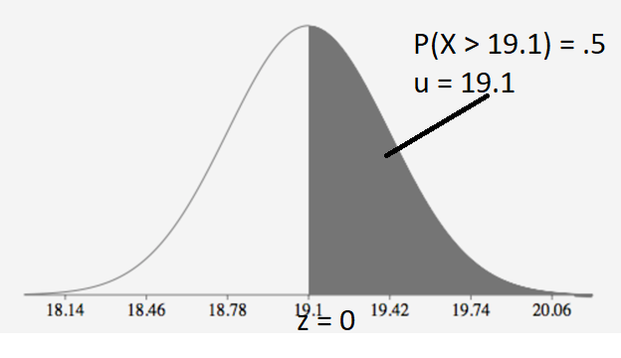

1. P(X > 19.1) = 0.2 P(z > .84) = .2

.84 = 19.1 – u / 0.32 u = 18.8312

u is less than 19.1

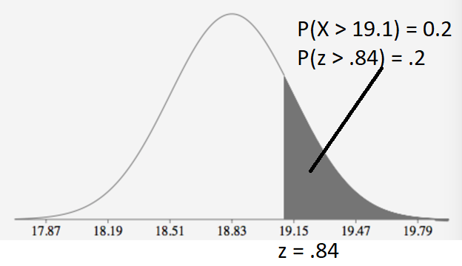

**#5.17, #5.38, #5.44, #6.37 and #6.66.** **For each part of the above problems, draw a normal curve, highlight the corresponding area and mark the z-value on the x-axis.**